MEKELLE UNIVERSITY

Ethiopian institute of technology - Mekelle
Department of computing
Software engineering
Process management
Web based restaurant

Group Members
No. | Name | ID
1 | MEAREG TEFERI | EITM/UR158176/11
2 | ZEHARA KASSAW | EITM/UR158553/11
3 | LEWAM YEMANE | EIMT/UR158539/11
4 | NAHOM GIDEY | EITM/UR159379/11
5 | TEDROS G/HER | EITM/UR157777 /11

Table of Contents
List of tables viii
List of figures ix
Abstract xi
List of Abbrivations xii
Chapter 1 1
1. Introduction 1
1.1 Background 1
1.2 Statement of the Problem 1
1.3 Purpose of the project 2
1.4 Objective 2
1.5 Feasibility Study 3
1.6 Scope and Limitation 4
1.7 Significance of the project 5
1.8 Target beneficiaries of the project 6
1.9 Requirement specification 7
1.10 Methodology 8
1.11 Testing plan 9
1.12 Task and schedule 10
1.13 Team Composition 11
Chapter 2 12
2. Description of the Existing System 12
2.1 Introduction of Existing System 12
2.2 Players in the Existing System 13
2.3 Major Functions/Activities in the Existing System 14
2.4 Business Rules 14
2.5 Bottlenecks of the Existing System 13
2.7 Practices to be preserved 14
Chapter 3 15
3. Proposed System 20
3.1 Overview 20
3.2 Functional requirements 20
3.3 Non-Functional Requirement 21
3.4 Performance Requirements 22
3.5 Identification of actors and use cases 23
3.6 Use Case Model 17
3.7 Class Diagram 24
3.8 Sequence Diagram 25
3.9 Activity Diagram 30
3.10 User Interface Prototype 33
Chapter 4 34
4. System Design 34
4.1. Introduction 34
4.2. Class type architecture 34
4.3. Class modeling 36
4.4. State chart diagram 37
4.5. Collaboration Diagram 40
4.6. Component diagram 42
4.7. Deployment diagram 43
4.8. Persistence modeling 43
Chapter 5 44
5. Conclusions and Recommendation 44
5.1. Conclusion 44
5.2 .Recommendation 45
References 46

List of tables
Table 1: Team Composition 9
Table 2: Register Use Case Description 19
Table 3: Log in Use Case Description 19
Table 4: Manage Profile Use Case Description 20
Table 5 Select Dish Use Case Description 21
Table 6: Manage Basket Use Case Description 21
Table 7: Add Dish Use Case Description 22
Table 8: Place Order Use Case Description 23
Table 9: Make Payment Use Case Description 24

List of figures
Figure 1 Gantt Chart 9
Figure 2 Use Case Diagram 18
Figure 3 Class diagram of the food delivery system 25
Figure 4: Log in Sequence Diagram 26
Figure 5: Manage cart Sequence Diagram 27
Figure 6: Add Dish Sequence Diagram 28
Figure 7: Place Order Sequence Diagram 29
Figure 8: Register Activity Diagram 31
Figure 9: Log in Activity Diagram 32
Figure 10: UI prototyping for restaurant 33
Figure 11: System architecture 36
Figure 12: Class diagram 37
Figure 13: State chart diagram for login 38
Figure 14: State chart diagram for add dish 38
Figure 15: State chart diagram for place order 39
Figure 16: Collaboration Diagram of the System 40
Figure 17: Collaboration Diagram for login 41
Figure 18: Component diagram 42
Figure 19 Persistence Diagram 43

Abstract
Unfortunate circumstances like disability, old age, pandemics and busyness, prevent many from going out and getting food. An online food ordering and delivering system can help those who find themselves in those unfortunate situations. web Based restaurant System is a project that aims to make online food ordering and delivering systems more efficient and more modernized. The system serves as a web-based communication platform for customers, food vendors and food couriers to order and deliver food quickly and effectively. The project is implemented by using the mobile applications and the web applications used to build the necessary structures that make up the system. The web applications are developed using React. The database system and overall backend are developed using MongoDB.

List of Abbrivations
API Application Programming Interface
UI User Interface
UML United Modeling Language

Chapter 1

1. Introduction

1.1 Background
The first food order and delivery were recorded was in 1889 when the visiting royal couple of Savoy wanted to try the food of the people of Naples. [1] Since then it has evolved, making use of new technologies. From orders being taken by phone calls to now through the internet.
Nowadays food is ordered online and using mobile and web applications. Companies like Uber Eats and Grubhub operate in many major cities making it possible for users to choose, order and track food from wherever they are. These companies even managed to become the major source of food for many during the Covid 19 pandemic. [2]
These online food ordering and delivering companies have also been popping up in Addis Ababa in recent years. beU, Moteregnaw and Deliver Addis being one of the many that has sprung up around the city. The number of companies in the industry are rapidly rising in Addis Ababa. [3] This project aims to stand out amongst them.
By using a web-based system and GPS tracking we plan to make a food ordering and delivery system that connects hotels, restaurants, bakeries and any other institution that offers food with couriers and customers.
The system acts as a mediator between the food service providers, the couriers and the customers to create a cohesive environment that brings these entities together where every party is satisfied. The grand aim of the whole project is to make a comprehensive system that will revolutionize food delivery in Addis Ababa.

1.2 Statement of the Problem
Modern cities like New York, London, Beijing and other major cities of the world have become more and more modernized [4]. Their economy is shifting away from physical location and toward the digital and internet. Ethiopian cities, on the other hand, lack any form of delivery service, much alone a web-based food delivery system. It's reasonable to state that web-based food delivery services do not exist in Ethiopia's capital. The few food delivery applications and systems that exist in our nation, which can be counted on one hand, are not web-based and are reliant on hired people tasked with delivering the food, limiting the system's potential to the employees' ability.
It's tough for an Addis Ababa resident to order food from their favorite restaurant using an app and have it delivered to their front door. There is no comprehensive list or catalog of restaurants from which to locate and select the preferred eatery. Customers can't track their food while it's being delivered to their house using existing applications and systems, and there are no payment options available that assure a safe and secure online transaction.

1.3 Purpose of the project
The main purpose is to increase efficiency, make the ordering process a reliable and convenient transaction for both the customer and the service provider, minimize the manual data entry and ensure data accuracy and security during order placement process.

1.4 Objective

1.4.1 General Objective
The general objective of the project is to develop a web-based restaurant System

1.4.2 Specific Objectives
To accomplish the above general objective, we have applied the following specific objectives:
- Gather data from potential users to identify the requirements
- Examine current systems to see how they can be improved
- Design a system that absolves the shortcomings found in examining the current system
- Test component in the system during step of development

1.5 Feasibility Study

1.5.1 Technical feasibility
Most people these days have a smart phone and have a knowhow about using them, like any other system. Since we plan to design a user interface that is easy to learn and use for everybody as far as possible by following best UI design principles and guidelines that are widely used by industry professionals. In order to build this application, we are using node js for the back-end and React and React for the front end. These technologies are the latest available tools that are efficient and the most fitting to our vision. We chose React because React is great for web apps. It provides a slick, smooth and responsive user interface, while significantly reducing load time. It's also much faster and cheaper to build apps in React as opposed to building another one, without the need to compromise on quality and functionality. [5] And for the back-end we chose node because it is very flexible.

1.5.2 Operational feasibility
The system is implemented in a web application form for all entities involved. It has a common, easy to use and effortlessly understandable interface for any user that has had any experience with other web applications or web application before. It incorporates a log in page that the user needs to sign up with a password and a preferred account (phone number or email address), when the user starts off. After the first log in, the user has no need to log in again on the same device unless specific situations relating to the device arise. The user would also need to log in if devices are changed. The account is be valid in infinite number of devices.

1.5.3 Economic Feasibility
To check if our system is economically feasible first, we have to consider the cost and benefit ratio. The cost that we provide for the system are minimum because most of the service we used are either free or have a student account or their paying system is with “Pay as you go” approach which allows you to easily adapt to changing business needs without over-committing budgets and improving your responsiveness to changes. With a pay-as-you-go model, you can adapt your business depending on need and not on forecasts, reducing the risk of over provisioning or missing capacity. Which is a great condition for us because we built this system for study purposes but if we are going to deploy this system to a real world, we won’t have to spend a lot of money from investor for the system deployment because the system will make us the money as it progresses and we will get charged based on our number of customers.

1.6 Scope and Limitation

1.6.1 Scope
The scope of this system includes allowing customers to request food delivery, ordering food from the restaurant, and delivering the food to the customer who requested the service. This system is being introduced in Addis Ababa, Ethiopia's capital city. This is because a third-party firm based solely in Addis Ababa provides the system with numerically encoded positional data, such as street and address house numbers. In addition to this 3rd party organization.

1.6.2 Limitation of the project
Some limitations of the system are:
- The service is only available in Addis Ababa because the positioning system is only available there.
- Risk of power outages and loss of internet connection.

1.7 Significance of the project
The internet and technological advancements are having a great impact on people spending a big part of their day on the internet, it provides a huge market potential for restaurants.
As the research shows in the year 2020/21, 20% of Ethiopian people use internet [7], and these behaviors continue to affect how businesses operate in the restaurant industry. It provides a huge market potential for restaurants. In fact, the demand for online restaurant ordering continues to grow among restaurant consumers and restaurant owners consistently look for solutions that allow customers to place orders online and have food delivered fast. An online ordering and delivery system is crucial for the modern restaurant, it contributes to higher sales volumes and greater customer satisfaction.
Creating and maintaining a great-looking menu that entices clients to purchase from you every time they see it is far easier and much less expensive (or even free). Restaurants not only free themselves from the hassle of printing and publishing expenses, but they also gain a great deal of freedom in modifying the menu whenever they choose. Furthermore, with a superb online menu, up-selling is automatic, which means that if customers see the dessert page, there is a higher probability they’ll order it along with their main meal.
In any restaurant, whether an order is accepted over the phone or in person, miscommunications can occur. Honest errors can result in spoiled food and, more crucially, irritated customers who may not return. For restaurants, one of the advantages of web-based ordering is that the consumer has more control. When the client is in charge, they feel more in control of their activities and have a better grasp of what they are doing. There's no risk of a mix-up because everything is written down.

1.8 Target beneficiaries of the project
The project benefits everyone in the entire supply chain. Restaurant get to get to sell more and courier who deliver the food will have a cut from every delivery.
Restaurant get to present its products to a much larger customer base than if it only use manual system. Online customers get much more convenience, access to a larger selection of foods, and more competitive prices.
Targeted Beneficiaries
- Restaurant:
Restaurant is the main targeted entities that are expected to benefit most through this project.
- Customer:
The customers gets to choose foods from diverse choice of food which in turn save inappropriate wastage of time that's caused by manual searching of food.

1.9 Requirement specification

1.9.1 Hardware specification
We built a web application.
The system can be accessed from a mobile, tablet or computer (recommended) because there may be an ordering traffic the device should be high end.
- Processor: Minimum 1 GHz; Recommended 2GHz or more
- Ethernet connection (LAN) OR a wireless adapter (Wi-Fi)
- Hard Drive: Minimum 32 GB (for tablet or computer); Recommended 64 GB or more
- Memory (RAM): Minimum 1 GB; Recommended 4 GB or above
There is no absolute hardware requirement that must be included for the web app because most of the things are done in the back end the customer web app only use to render the services and take an input from the user.

1.9.2 Software specification
The tools and software’s used in this project are: -
- Lucid charts: To make all the UML Diagrams and charts.
- Microsoft word: To make the documentation of the system.
- NodeJS: NodeJS is an open-source JavaScript framework, designed for building web app backend on web applications, utilizing the very same code base. It is based on JavaScript, and it brings all its glory to web app development.
- React: React allows developers to create large web applications that can change data, without reloading the page. The main purpose of React is to be fast, scalable, and simple. It works only on user interfaces in the application.
- Visual Studio Code: Visual Studio Code is a streamlined code editor with support for development operations like debugging, task running, and version control. It aims to provide just the tools a developer needs for a quick code-build-debug cycle and leaves more complex workflows to fuller featured IDEs, such as Visual Studio IDE.

1.10 Methodology
Choosing the right software development methodology depends on your team structure, experience, project requirements, goals, budget, and other underlying factors. After considering this we have chosen Scrum Development Methodology as our methodology because Scrum is arguably one of the most flexible software development methodologies available. It is based on the Agile Development Methodology philosophy and is favored for its incremental and iterative approaches. The Scrum methodology involves the Product Owner, Scrum Master, and the Development Team. The product owner takes input from the client and ensures that the team is on track in fulfilling the client’s requirements. Meanwhile, the Scrum Master acts as a facilitator and ensures that team members are familiar with the Scrum process. The team takes charge of executing the development. What makes Scrum an ideal methodology in a fast-paced environment is how tasks are executed in sprints. Each sprint takes up to 4 weeks. The speedy execution allows teams to identify issues, introduce solutions, test, and gather feedback in a short period. It makes tackling fast-paced projects much easier.
Some of the advantage of using Scrum as a methodology
- Short iterations allow quick resolutions to problems.
- Scrum is very responsive to changes as the process includes regular feedback.
- Scrum is economical and effective.
- Regular meetings ensure that team members are on the same page at all times.
- Contributions of individual members are noticed and appreciated through the Scrum meetings. [8]

1.11 Testing plan

1.11.1 Unit Testing
Every good software product in the world has one thing in common, testing. Nothing comes out perfect and any design needs polishing to the upmost capabilities of the developer. Unit testing is one of the main areas of this project’s testing phase. The testing is divided into units that was tested individually. These units are but not limited to GPS tracking, payment system, authentication at log ins, rating system, order placing and verifying system and administrator management.
The testing process tests each individually testable component solitarily. The test restarts after every error fix. The test goes through each component’s code path when possible. Special tests are designed to test specific scenarios to find bugs.

1.11.2 Integration Testing
After the unit testing is done, we must do an integration testing to see the camaraderie between the different units. The question the test seek to answer is if the system can function as a complete and one entity. The installing process on devices are tested. The testing also include the state of functionality of the components when they interact with each other.
The order placing and verifying unit must be able to work together with the payment and GPS tracking units smoothly. Smooth transactions are the backbone of our system. As such, transaction testing is crucial for our system to be efficient and functional. For this, we created test cases and use cases to track every step of the interaction. We run tests using the use cases, detect errors and finally do the tests again after the error has been fixed. The testing process is repetitive and consistent, beginning anew with every new feature added.

1.12 Task and schedule
Time management is critical in software development since it influences the project's outcome. Time management tactics can help you be more efficient and effective as a software developer. This is the schedule we've set for ourselves during the development process.
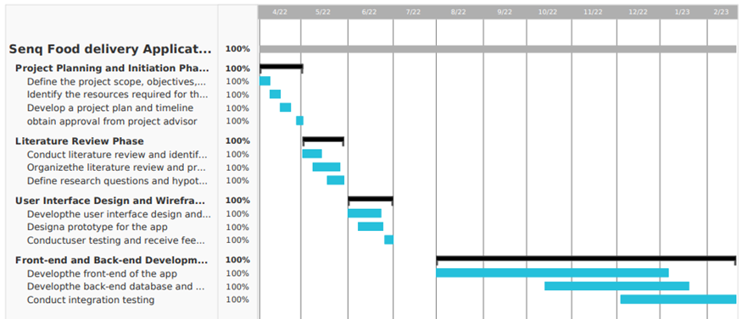
Figure 1 Gantt Chart

1.13 Team Composition
Here are the members of these team
Table 1: Team Composition
Project title
Prepared by | No | Name | ID | Responsibility
Prepared by | 1 | meareg teferi | eitm/ur158176/11 | All
Prepared by | 2 | zehara kassaw | eitm/ur158553/11 | All
Prepared by | 3 | lewam yemane | eitM/ur158539/11 | All
Prepared by | 4 | nahom gidey | eitm/ur159379/11 | All
Prepared by | 5 | tedros g/her | eitm/ur157777 /11 | All

Chapter 2

2. Description of the Existing System

2.1 Introduction of Existing System
As our current system there are few systems that we can take like Delivery Addis, Zmall Delivery But we decided to take beU Delivery as our main reference. beU is a successful food delivery service that mainly operates in Addis Ababa. It works with users ordering food through a mobile application from a restaurant found in a four-kilometer radius of their whereabouts. A biked deliverer employed by beU will take the order from the restaurant and deliver it to the user. The restaurant will be notified of the order via phone call from the beU office and the deliverer will pay cash when he/she takes the food from the restaurant.
BeU delivery is one of the pioneers in the online food delivering service in Ethiopia. It has laid the critical groundwork in its field that will be vital for future companies. However, its system is inefficient. Currently the mobile application is only used to notify the office what the user wants. The order tracking and paying system are all handled through phone calls and face to face. Since the number of orders that can be delivered through phone calls is limited by the number of operators tracking orders, growth in the number of orders will be debilitating for the company.
Even if beU has enough restaurants contracted to deliver a large amount of food every day, the system will be an anchor to its growth. The more foods and orders come, the more deliverers and more phone operators beU will have to hire, which will inevitably put a strain in the financial capacity of the company. These can be seen in the reviews left behind by frustrated users whose orders has been delivered late or not delivered at all. beU is increasing the workload on a manual force, when the technology exists for it to be automated. Relying on backward systems when better one exists might eventually lead to beU itself becoming outdated.

2.2 Players in the Existing System
Customer: the person that uses the system to order the food. The customers can be anyone within the range of 4km around the restaurant. Because beU deliver uses bicycles and motors for delivery system and their coverage area is small. And also, the customers should download the app and have an internet access. The customer doesn’t need to create an account because the paying system is not native inside the app rather it’s in cash, but if the customer wants to have a discount or coupons, they must create account.
Deliverer: in our current system which is beU delivery the deliverer is working under the company as a permanent worker. Not anyone can be a deliverer you should apply for a job in order to be a deliverer. The condition varies from company to company but most of them includes these preconditions. The deliverer must have the skill to use a bike or motorcycle. The deliverer must have an understanding of using the existing system. The deliverer must give personal information copy like driver license for motorcycle and ID or passport.
The service providing company: this are the companies that made the system and administer it along the way. They also provide maintenance and updates too. We used beU delivery for our main reference as existing system. This app was developed by binary technologies which is based in Addis Ababa. Their main job after building the app was compelling the hotel and the customers to get into the system and after that they manage orders and deliveries inconsistencies which may happen in the system.
Restaurant: they sign agreement with the service providing company and will register to the system as one stakeholder. In our existing system which is beU delivery the hotels agree with the binary software and after signing the agreement their food will be available for order in the app.in the existing system the hotels and the service providing company will be connected through some media. The company will call the hotel if there is any orders. Then after the food is ready the hotel will call back to the company and the company will assign the deliverer.
Operator: a person that works in the service providing company that will connect the customer, the hotel and the deliverer. First after receiving the order the operator will call the customer to verify the order after that the operator will call the hotel if there is any change and also manages orders in order to make sure that all orders are placed to the hotels. Operators are permanent workers at the service providing company.

2.3 Major Functions/Activities in the Existing System
The traditional version of ordering food for a takeaway service involves the customer physically going to the restaurant and placing an order. After ordering, the customer requests for a takeaway service. The food is packaged and given to the customer. Currently there are web pages and apps used to order food delivery. The following section summarizes the function of existing computerized system with their input, process and output.
Input:
From customer, the inputs to the system from customer are phone number, Name and location data. The customer phone number is used to contact the customer, the name for security purposes and location data for delivery. The customer enters this inputs in-order to acquire an account.
From restaurant, the inputs to the system from restaurants are phone number, menu list, and location data. The phone number is used to receive orders and communicate any issues that arise during production. A complete menu list containing pricing and dietary restrictions is required from the restaurant. The location data is used for delivery purposes.

2.4 Business Rules
The main business rules or principles for a restaurant are: -
- The restaurant is responsible to set-up phone line in order to receive orders phone.
- The restaurant should communicate any issues that will affect the delivery time using the phone to the admin
- The restaurant must complete orders and have them ready within 20 minutes after the order is confirmed by the admin
- All orders must be labeled and packaged in accordance with rules.
- To properly mark all menu items with the dietary restrictions that apply to them.
The main business rules or principles for Administrator are: -
- To collaborate on a meal plan with the restaurant.
- To provide delivery and customer service for orders to the restaurant
- To notify and confirm orders via phone call to the restaurant’s phone number
- To provide delivery and customer services for orders to the restaurant
- To inform any type of changes that will affect the delivery time of the order
The following are shared business rules and principles by the restaurants and the admin: -
- The restaurant and the service provider should agree on an administrative service charge fee from each order to be paid to the service provider.
- The restaurant and the service provider should agree on the cost of correcting errors in accordance to where these errors originate from.

2.5 Bottlenecks of the Existing System
For reference of existing systems, we can take a look at both beU delivery and manual traditional food ordering. BeU delivery’s flaw lies in the system being new, relies on traditional methods too much and lacks accurate locating systems. The traditional food ordering system in other hand has an obvious disadvantage concerning time management and efficiency.

2.5.1 Input (Inaccurate/Redundant/Flexible) and Output (Inaccurate)
The existing system takes inputs from the users. Some of these inputs are entered while creating an account such as phone number and emails which can be used to validate the account, this is a one of the good qualities about the existing system. The system also takes location of users by the users entering it rather than GPS which leads to inaccurate inputs. This will lead to order cancellation or inaccurate delivery.

2.5.2 Security and Control
In order to access the existing system, one must already have an account to login or create account; in both cases the system is secure. This way the users account is secured and can be only accessed by the user only.

2.5.3Efficiency
According to the comments of some users of the existing system on Google play store, most users agree the system is “inefficient. The orders get canceled out of nowhere and the users don’t get any notification whatsoever. The system takes a lot of time to load and to display available foods. The users cannot track their food, and they do not have any idea where their food is, its status or whether or not it is being made.

2.7 Practices to be preserved
The existing system have some good qualities that worth preserving. The user interface is one of them, beU delivery mobile app have a great looking user interface that can attract a user and will make them visit the app again. We have preserved the following practices from in the existing system.
- The Authentication system.
- The flexibility and simplicity of the user interface.
- The identification of orders by unique order number.
- Using of GPS.

Chapter 3

3. Proposed System

3.1 Overview
This project uses an object-oriented development as a guideline. Object oriented programming aids the project by reducing the development time, reduces the resources required to maintain existing applications and increase code reuse.
In this chapter the relationship between the different entities and their function is laid out using UML diagram. These UML diagrams are divided into four parts, Class, Sequence, Activity and Use Case diagrams.
User Interface prototype diagrams are also included in this chapter. The prototypes are not real representation of the Web Based Restaurant system.

3.2 Functional requirements
- The system lets the customer register or create a new account.
- The system lets the customer login if they already have an account
- The system lets all the users manage an account.
- The system lets the customer navigate through the app to place an order.
- The system lets the customer search any dish or restaurant.
- The system lets the customer select a dish from the menu.
- The system lets the customer add a dish to their order basket.
- The system lets the customer remove a dish from their order basket.
- The system lets the user place an order.
- The system lets the user view an order.
- The system lets the user pay in a different way.
- The system lets the user track an order.
- The system lets the restaurant create an account with a different registration requirement, like the physical address verification procedure, legal business information.
- The system lets the restaurant add a new dish into the menu.
- The system lets the admin login to the system.
- The system lets the admin manage the restaurant account like validation of the documents and agreement.

3.3 Non-Functional Requirement
- There is a simple registration process that can be easily and efficiently done.
- Users easily find the food they want easily. Without no multi step checkout like users must reach the “Add to basket” button in one step.
- Only the system data administrator can assign roles and change access permissions to the system. The system is resilient to any kind of attacks.
- The system loads in less than 4 seconds.

To properly judge the performance of web-based restaurant a criterion must be met. These criteria are listed above as Non-functional requirements.

3.4 Performance Requirements
The purpose of this section of the document is to outline the Software Performance requirements of our system. The following scales are used to measure the performance of the system: -
1. Response Time
Software:
The system developers warrant that in supporting 2,000,000 customers it shall ensure that performance shall not fall below the following level: 90% of ALL visible pages for “normal” customers respond in 3 seconds or less.
Measurement Points:
The timer measures the time from the request for a page to when the last bit required to render the page is returned. Backend response times are measured using the application server log files.
2. Workload:
The software supports 30,000 customers which will on a busy day generates 7000 customers
3. Scalability:
The system developers warrant that the food delivery system is capable of supporting at least unlimited customers when implemented into a suitable production environment.

3.5 Identification of actors and use cases
Actor Identification:
An Actor in the Unified Modeling Language (UML) "specifies a role played by a user or any other system that interacts with the subject. The followings are a list of Actors in the Proposed System.
Customer: The person that uses our system to order a dish from the restaurant. The customer may be a new user or an existing user.
Restaurant: Is an organization in our system that provide the dishes to the customer. The restaurant needs to provide additional documentation and legal agreement document when registering.
Administrator: The person who manages the entire system. There may be an issue occur in the system in this case the administrator can take charge and fix the issue. The Registration process of the courier and the restaurant would be verified by the administrator.

3.6 Use Case Model

3.6.1 Use case diagram
A use case diagram is a way to summarize details of a system and the users within that system. It is generally shown as a graphic depiction. n of interactions among different elements in a system. [9]
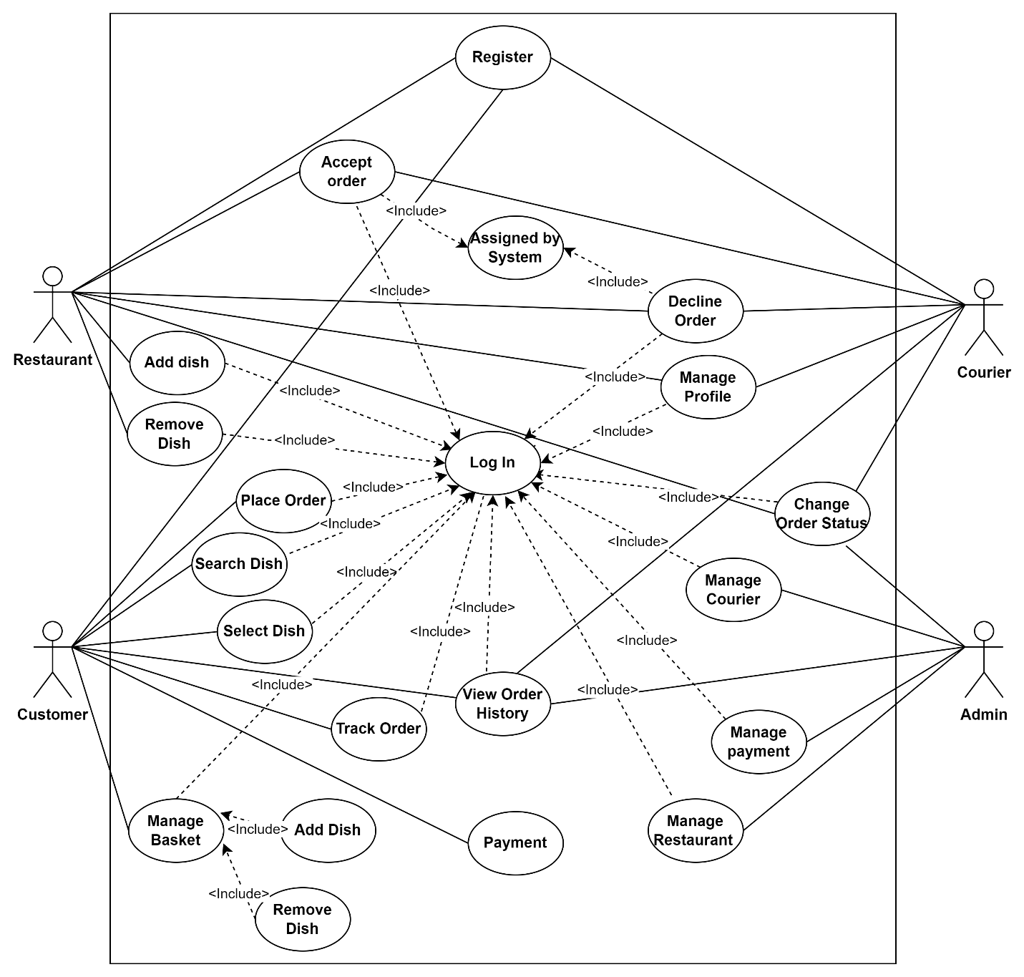

Figure 3 Use Case Diagram

3.6.2 Description of use case model
Table 2: Register Use Case Description
Use Case – UC-1 | Register
Related Requirement | Req-1, Req-14, Req-21
Initiating Actor | Customer, Restaurant
Actor’s Goal | To create account
Participating Actors | Customer, Admin
Pre-conditions: | The Customer, Restaurant and Admin must have access to the system
Post conditions | The customer, Courier and Restaurant have an account
Basic course of action for Actor | Actor Action  1. The Actor selects sign up option in the customer app  3. The Actor fills all the information  5. The Actor inputs the verification code | System Response  2. The system displays registration form  4. The system sends verification code  6. The system creates a new account for the Actor and forwards the Actor to the main page
Alternative course of action for the Actor | 7. If the Actor enters wrong information,  9. If the Actor enters duplicate account | 8. The system displays error message  10. The system display “information already exists” message.

Table 3: Log in Use Case Description
Use Case – UC-2 | Log in
Related Requirement | Req-2, Req-21, Req-28
Participating Actor | Customer, Admin
Actor’s Goal | To gain access to their account
Pre-conditions: | The Customer and Admin must have an already existing account
Post conditions | The Customer and Admin logins to the system
Basic course of action for Actor | Actor Action  1. The Actor selects log-in option in the Actor app  3. The Actor fills all the information (user-name and password)  5. The Actor is forwarded to the main page | System Response  2. The system displays Actor log-in page  4. The system verifies the user-name and password
Alternative course of action for Actor | 6. If the customer enters wrong information (user-name and password) | 7. The system display error message

Table 4: Manage Profile Use Case Description
Use Case – UC-3 | Manage profile
Related Requirement | Req-4
Participating Actor | Customer
Actor’s Goal | To change user-name, email address or/and phone number information
Pre-conditions: | The Customer must log in to the system or must already be logged in
Post conditions | Changed profile information of customer
Basic course of action for Actor | Actor Action  1. The Actor selects edit profile option in the customer app  3. The Actor edits their information | System Response  2. The system displays Actor profile page  4. The system confirms the edited information and displays a confirmation message
Alternative course of action for Actor | 5. If the Actor enters invalid information (user-name and password) | 6. The system displays error message

Table 5 Select Dish Use Case Description
Use Case – UC-10 | Select dish
Related Requirement | Req-7
Initiating Actor | Customer
Actor’s Goal | To select dish
Participating Actors | Customer
Pre-conditions: | Select restaurant
Post conditions | Displays the description of the selected dish
Basic course of action for the actors | Actor Action  Step 1: The customer selects restaurant  Step 3: The customer selects a dish from the display  Step 5: The customer confirms the selected dish | System Response  Step 2: The system shows all dishes available in the restaurant  Step 4: The system asks for confirmation
Alternative course of action for the actors | Step 5: If the customer didn’t select a restaurant | Step 6: The system display “No such dish ”

Table 6: Add Dish Use Case Description
Use Case – UC-12 | Add Dish
Related Requirement | Req-4, Req-5, Req-6, Req-7, Req-8
Initiating Actor | Customer
Actor’s Goal | To add a dish in the order basket
Participating Actors | Customer
Pre-conditions: | The Customer must log in to the system or must already be logged in  The Customer must select a single restaurant
Post conditions | The Customer adds a dish to their basket
Basic course of action for the customer | Actor Action  Step 1: The Actor selects a dish | System Response  Step 2: The system adds the dish in the basket

Table 7: Place Order Use Case Description
Use Case – UC-14 | Place Order
Related Requirement | Req-10, Req-11
Initiating Actor | Customer
Actor’s Goal | To place an order
Actor’s Goal | To approve or decline order
Participating Actors | Customer, Restaurant
Pre-conditions: | The Customer must log in to the system or must already be logged in  The Customer must select a single restaurant  The Customer must select at least one dish
Post conditions | The Customer can place an order
Basic course of action for the customer | Actor Action  Step 1: The customer adds dishes  Step 4: The customer selects the place order button  Step 6: The restaurant either approves or rejects the order | System Response  Step 2: The system put the added dishes in the same order  Step 3: The system makes the place order button clickable  Step 5: The system sends the order to the restaurant  Step 6: The system sends the restaurant’s reply to the customer  Step 7: The system displays an approved or a rejected message
Alternative course of action for the customer | Step 8: If the customer presses the back button before pressing the place order button | Step 9: the system displays a prompt to let the customer know the order will be lost if they exit without selecting the place order button.

Table 8: Make Payment Use Case Description
Use Case – UC-16 | Make payment
Related Requirement | Req-12
Initiating Actor | Customer
Actor’s Goal | To pay appropriate price for delivered food
Participating Actors | Customer
Pre-conditions: | The courier should have to deliver the food  The state of the process should be “delivered”
Post conditions | The customer can rate food
Basic course of action for the customer | Actor Action  Step 2: The customer selects payment options  Step 3: The customer pays the price of the food | System Response  Step 1: The system displays available payment options  Step 4: The system displays payment verification text
Alternative course of action for the customer | Step 5: If the customer gives insufficient price | Step 6: The system displays error message

Table 9: Add Dish Use Case Description
Use Case – UC-18 | Add Dish
Related Requirement | Req-6, Req-7, Req-8, Req-15
Initiating Actor | Restaurant
Actor’s Goal | To add available dishes on the restaurant dashboard
Participating Actors | Restaurant
Pre-conditions: | The restaurant should be logged in into the system
Post conditions | The system displays added dishes
Basic course of action for the customer | Actor Action  Step 1: Click add dish  Step 3: Customer enter details | System Response  Step 2: The system requests dish details to add  Step 4: The system adds dish
Alternative course of action for the customer | Step 5: If the dish is not unique | Step 6: The system displays error message.

3.7 Class Diagram
A class diagram is an illustration of the relationships and source code dependencies among classes in the Unified Modeling Language (UML). In this context, a class defines the methods and variables in an object, which is a specific entity in a program or the unit of code representing that entity. [10]

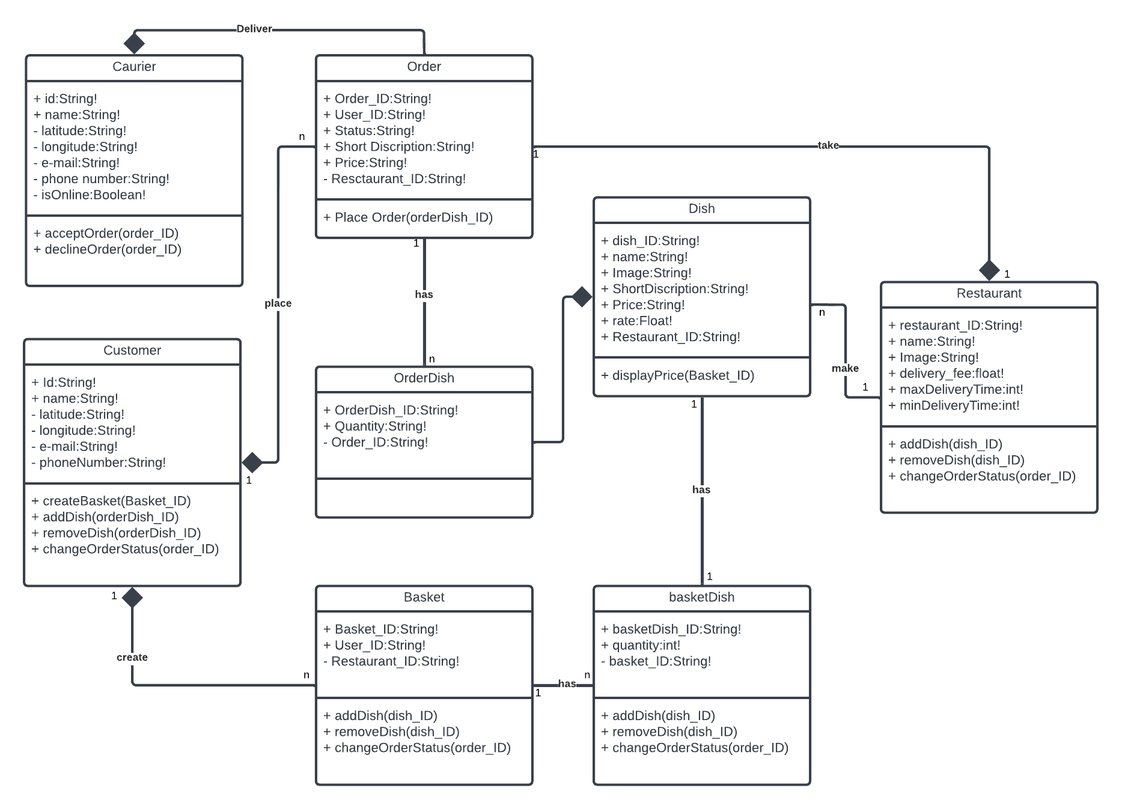
Figure 3 Class diagram of the food delivery system

3.8 Sequence Diagram
Sequence Diagrams are interaction diagrams that detail how operations are carried out. They capture the interaction between objects in the context of a collaboration. [11]
In sequence diagram, "Actors are external objects they don't need activation bars". [12]
- Sequence Diagram for Log in

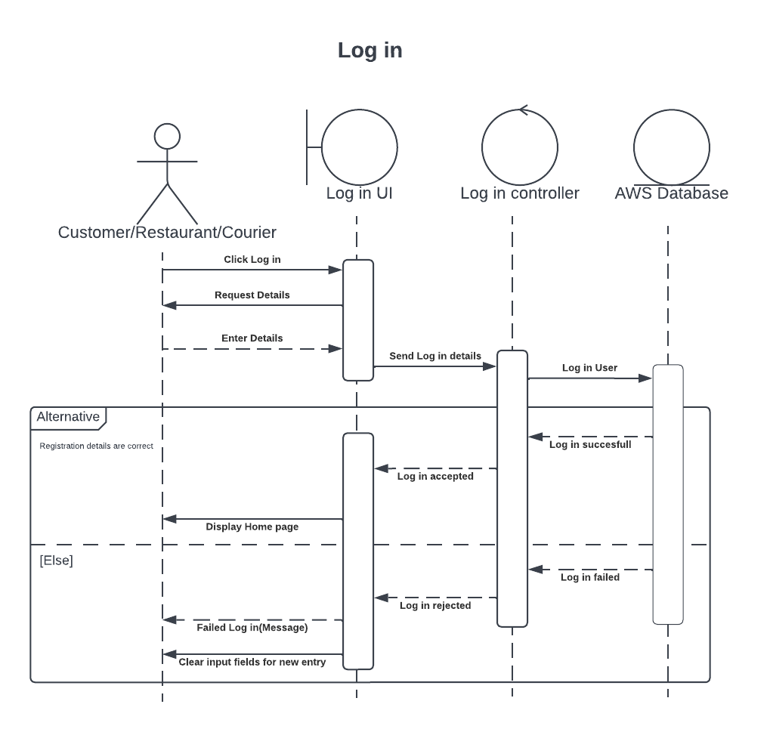
Figure 4: Log in Sequence Diagram

- Sequence Diagram for Manage Basket

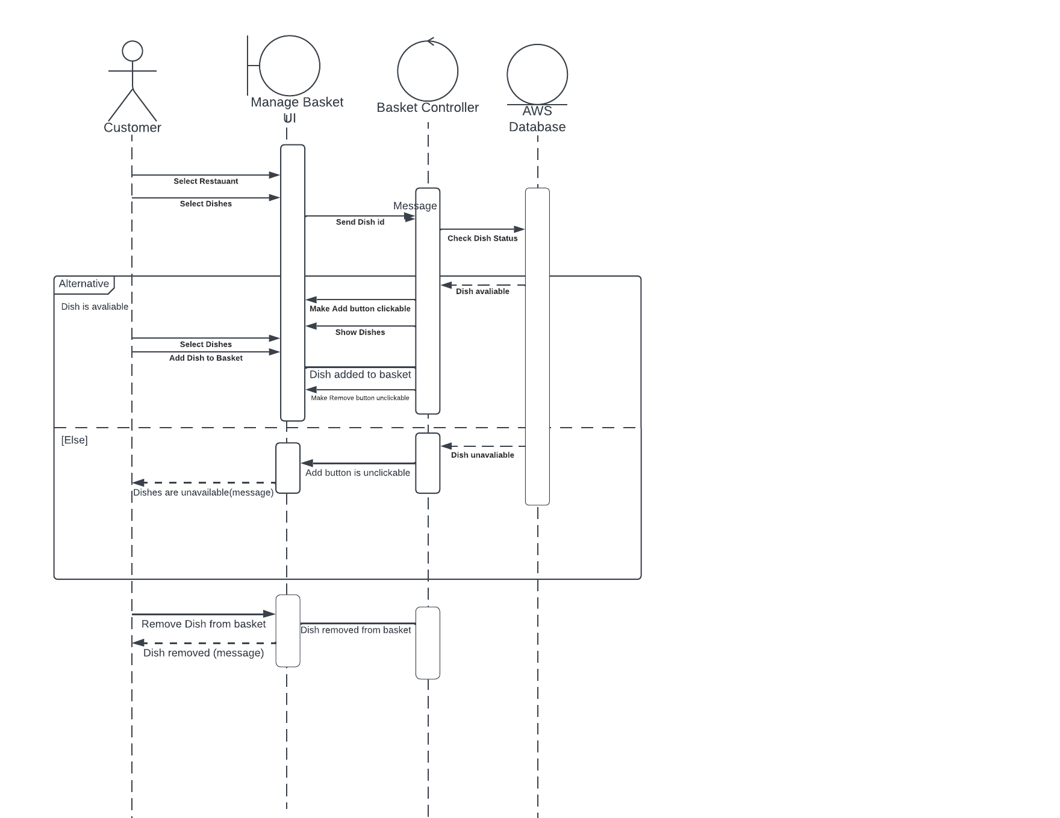

Figure 5: Manage Basket Sequence Diagram

- Sequence Diagram for Add Dish
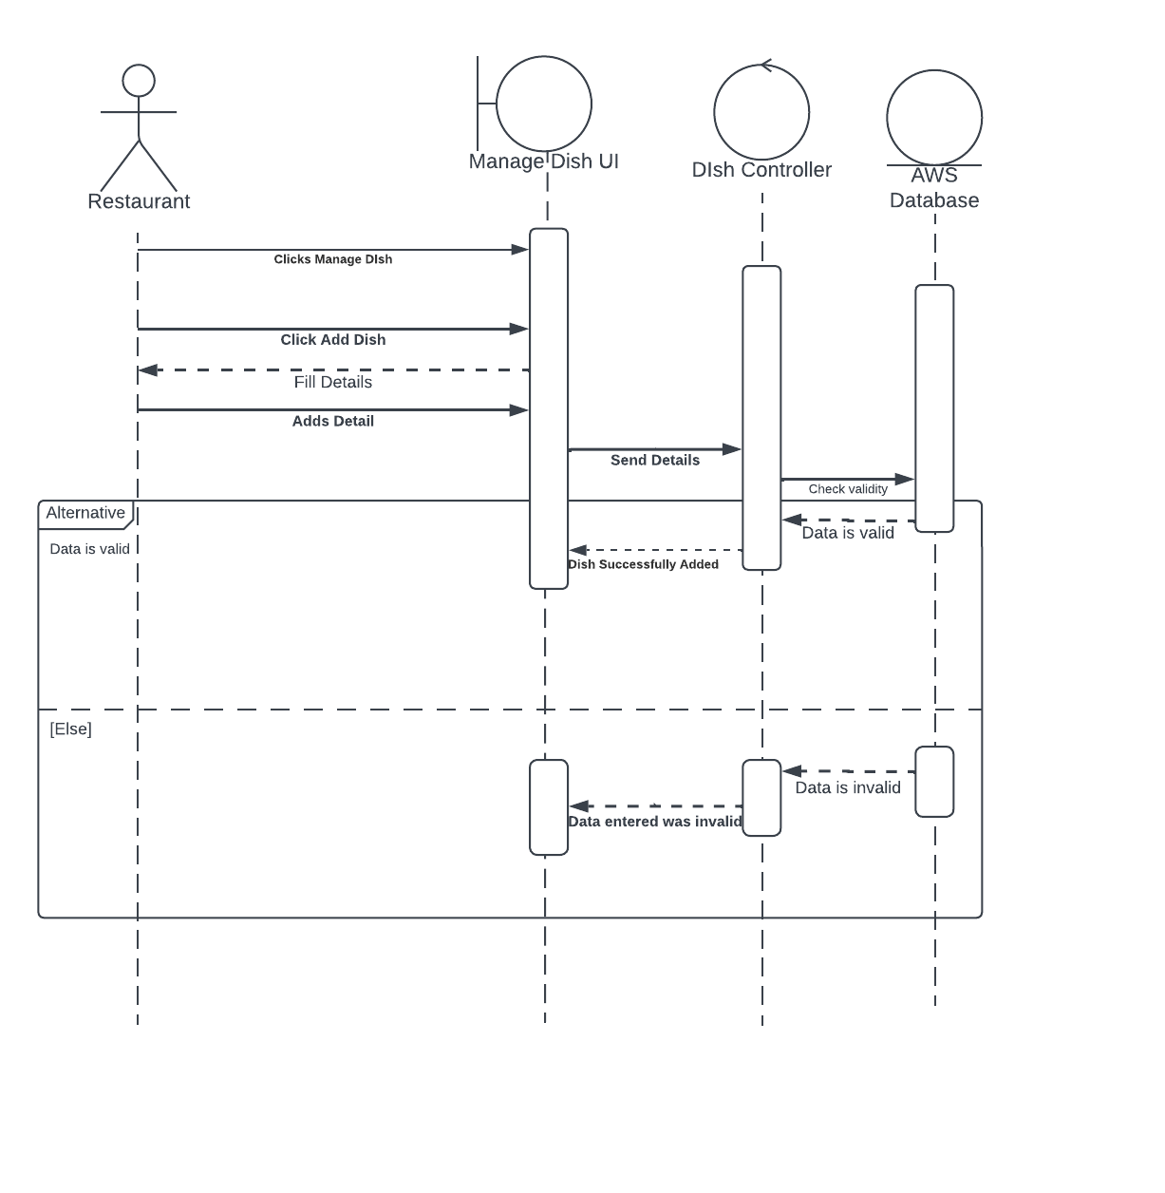
Figure 6: Add Dish Sequence Diagram

- Sequence Diagram for Place Order
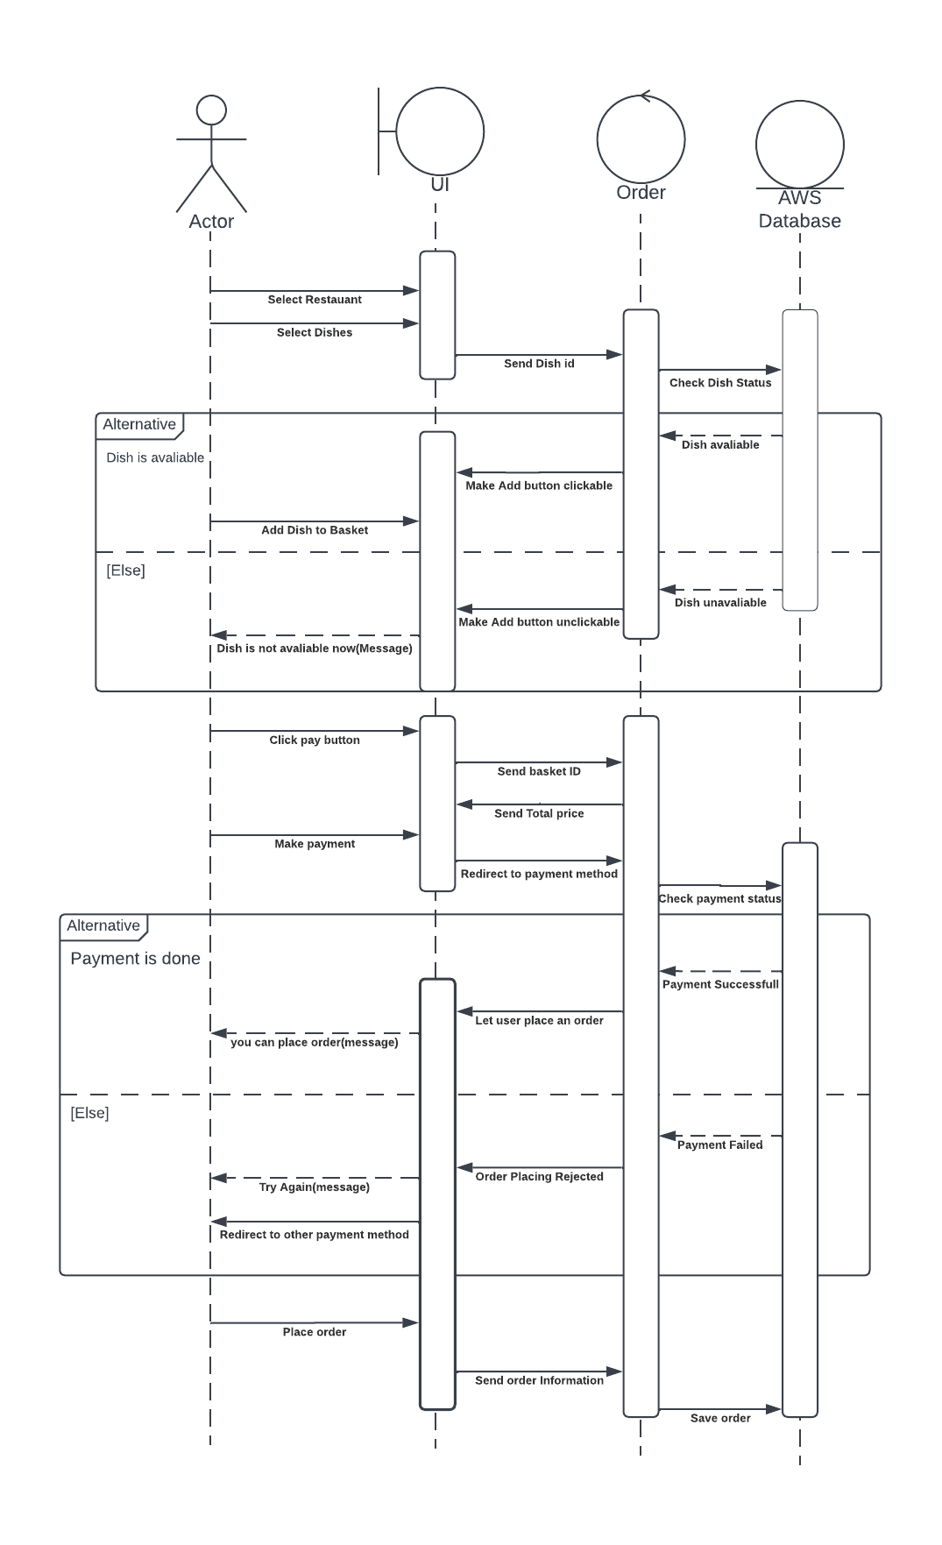
Figure 7: Place Order Sequence Diagram

3.9 Activity Diagram
An activity diagram visually presents a series of actions or flow of control in a system similar to a flowchart or a data flow diagram. [13]
  - Activity Diagram for Register
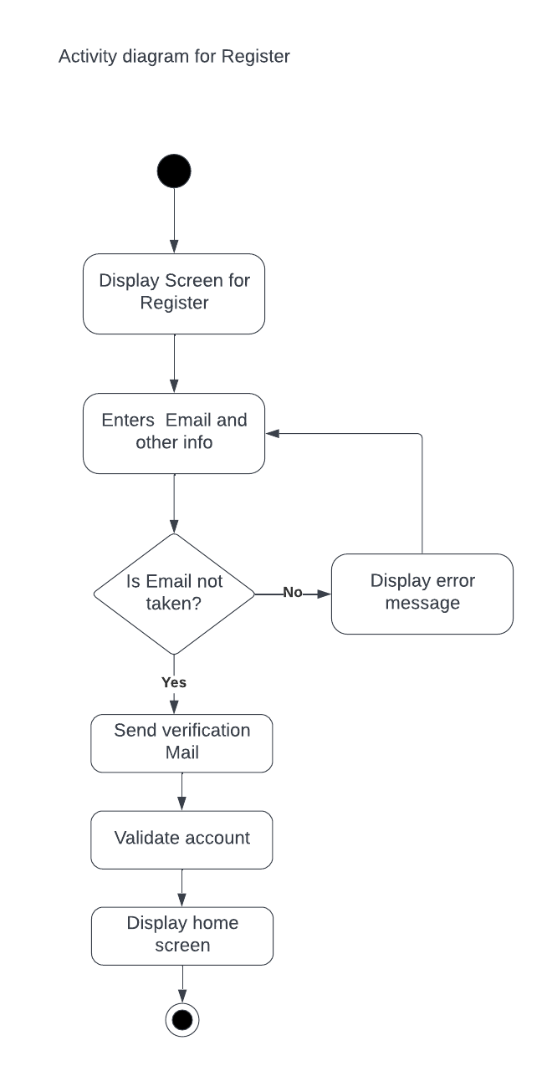
Figure 8: Register Activity Diagram

  - Activity Diagram for Log In
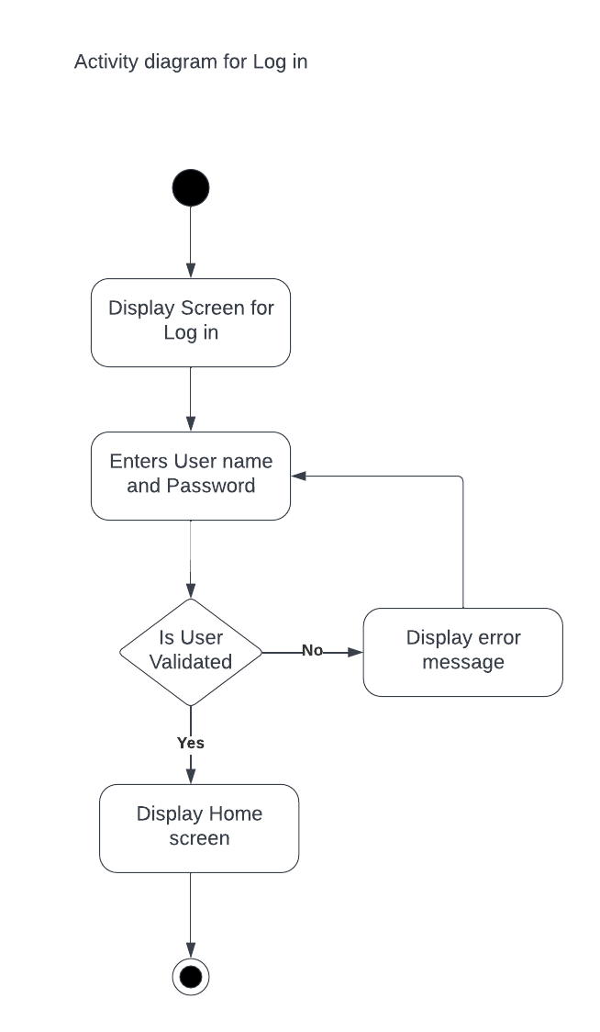
Figure 9: Log in Activity Diagram

User Interface Prototype
A prototype is a simulation of the real system. A prototype is essentially a tool for identifying and fine-tuning requirements. User interface prototypes are used to test the usability of the interface. The diagrams listed below are low-fidelity User Interface diagrams.

- Customer User Interface prototype Diagram
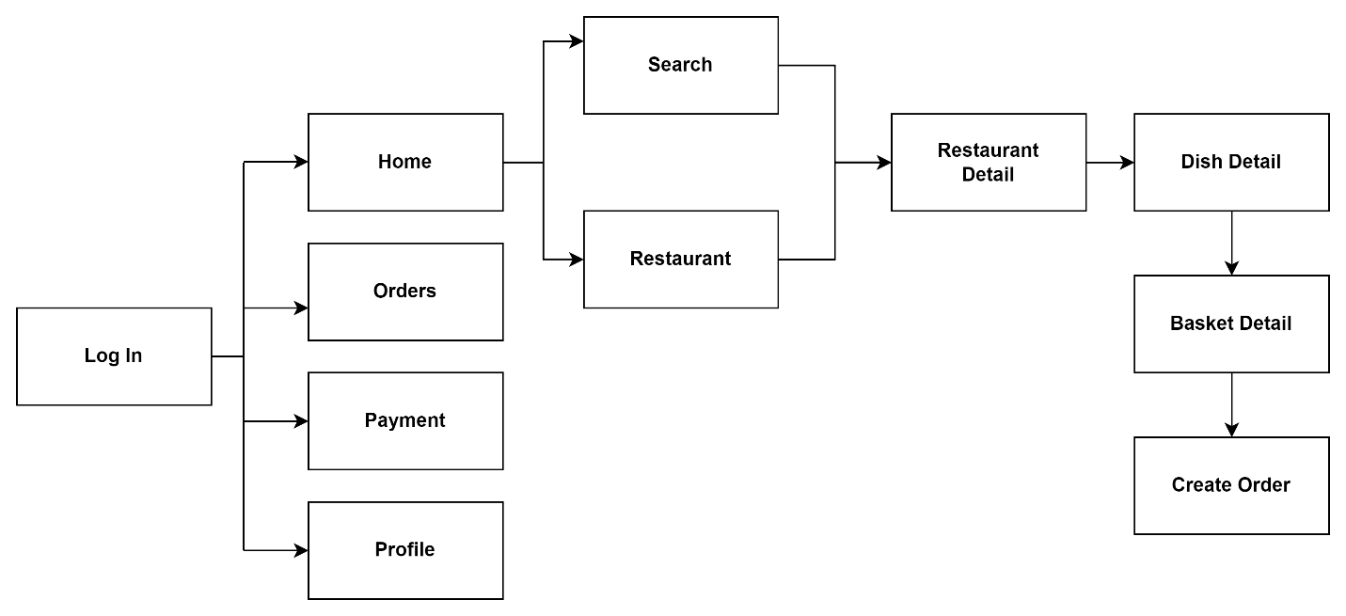
Figure 10 UI prototyping for customer web page

Chapter 4

4. System Design

4.1 Introduction
The conversion of the analytical model into a system design model is known as systems design. The design aspect of the web based food ordering and delivery system is the main topic of this chapter. This chapter's goals are to give a general overview of how to construct the suggested system and to gather the data required to determine how our system will really be implemented. We will examine various system modeling strategies in this part, including class diagrams, collaboration diagrams, state chart diagrams, component diagrams, deployment diagrams, and persistence diagrams.

4.2 Class type architecture
The entire layout and structure of a computer network or system are referred to as the system architecture. There are many different physical devices included, so a system is needed to arrange and link them in a logical way. Furthermore, sophisticated computer software tools are referred to by this name. A generic discipline termed "systems architecture" is used to handle "systems"—objects that now exist or will be created—in a way that encourages analysis of their structural characteristics. The conceptual model that specifies the structure, behavior, and other aspects of a system is known as its architecture.
  - User interface layer
UI layer, handles the interactions that users have with the software. It's the most visible layer and defines the application's overall look and presentation to the end-users. This is the tier that's most accessible, which anyone can use from their client device, like a desktop, laptop, mobile phone or tablet [1]

  - Controller/process layer
The application layer handles the main programs of the architecture. It includes the code definitions and most basic functions of the developed application. This is the layer that programmers spend most of their time in when working on the software. You can use this layer to implement specific coordination logic that doesn't align exactly with either the presentation or business layer [1]

  - Business/Domain layer
The business layer, also called the domain layer, is where the application's business logic operates. Business logic is a collection of rules that tell the system how to run an application, based on the organization's guidelines. This layer essentially determines the behavior of the entire application. After one action finishes, it tells the application what to do next [1]

  - Persistence layer
The persistence layer, also called the data access layer, acts as a protective layer. It contains the code that's necessary to access the database layer. This layer also holds the set of codes that allow you to manipulate various aspects of the database, such as connection details and SQL statements [1]

  - Database layer
The database layer is where the system stores all the data. It's the lowest tier in the software architecture and houses not only data but indexes and tables as well. Search, insert, update and delete operations occur here frequently. Application data can store in a file server or database server, revealing crucial data but keeping data storage and retrieval procedures hidden [1]
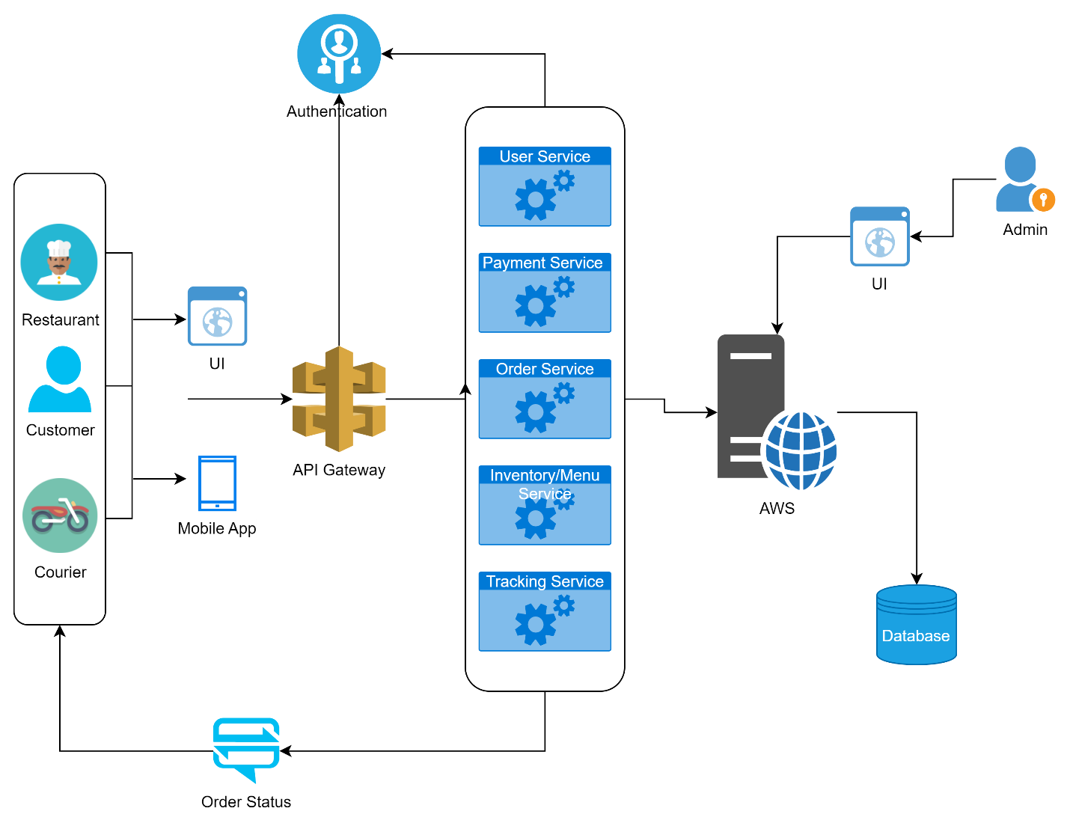
Figure 11: System architecture

4.3. Class modeling
A class diagram is a pictorial representation of the detailed system design. It is made up of a set of classes and interfaces that represent significant business domain entities for the system being modelled, as well as the interactions and connections between those classes and interfaces. Classes are placed in groups according to shared traits in a class diagram. In a class diagram, classes are represented as boxes with three rectangles inside each box, like a flowchart. The class name is in the top rectangle, the class's attributes are in the middle rectangle, and the class's methods, which are also known as operations, are in the bottom rectangle. The boxes are connected by lines, which could include arrows at one or both ends. These lines define the relationships, also called associations, between the classes.

Figure 12: Class diagram

4.4. State chart diagram
A state diagram, sometimes referred to as a state machine diagram or a state chart diagram, is a visual depiction of the states and transitions that an object in the Unified Modeling Language may experience (UML). An object's "state," which in this context refers to a specific entity in a program or the unit of code that represents that thing, specifies a stage in its development or activity. State diagrams are useful for many kinds of object-oriented programming (OOP). Even if the concept predates 10 years, it has improved as OOP modelling paradigms have developed. In a state diagram, the initial stage is denoted by a large black dot, while the next phases are depicted as boxes with rounded corners. One or two horizontal lines may separate the box into stacked sections. In this case, the state's name appears at the top, any appropriate middle part also contains state variables, and the state's activities appear in the lower portion. If there are no horizontal lines across a box, only the state's name is written inside of it. External straight lines with arrows at either end join several pairs of boxes together. These lines explain the changes between the states. The final state is represented as a significant.
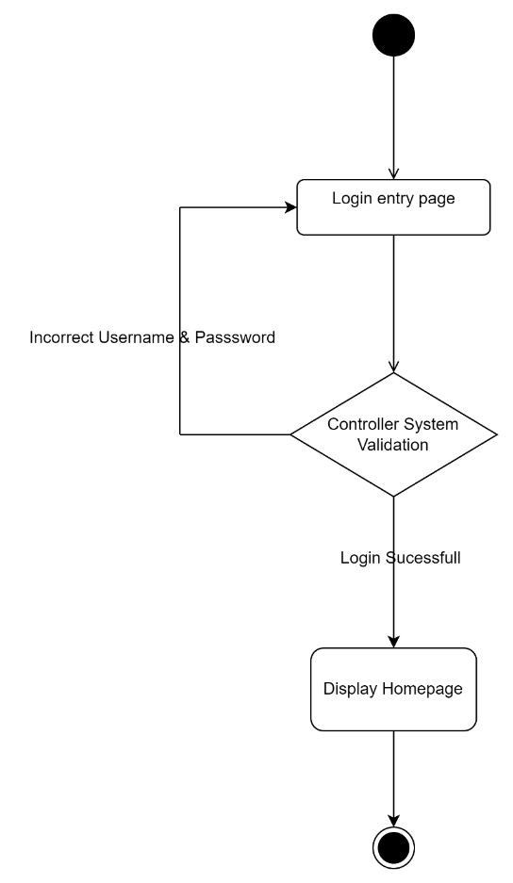
Figure 13: State chart diagram for login
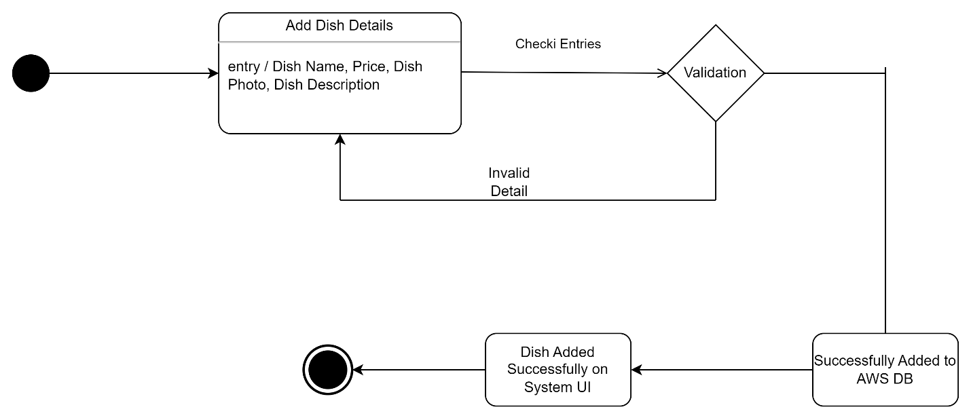
Figure 14: State chart diagram for add dish
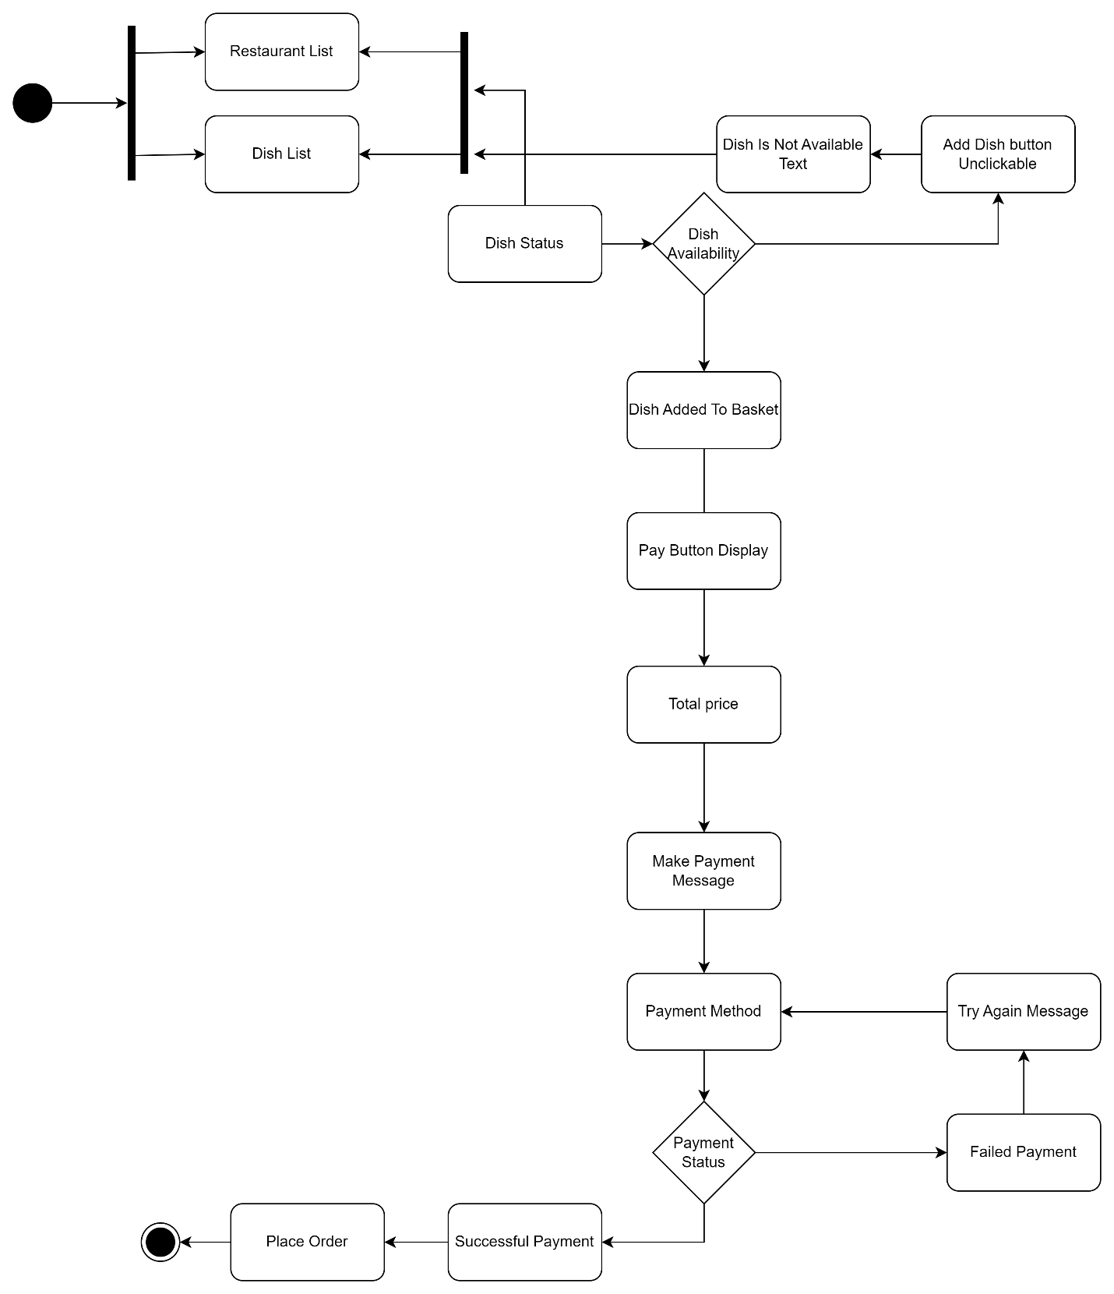
Figure 15: State chart diagram for place order

4.5. Collaboration Diagram
The first stage appears as a large black dot on a state diagram, while the succeeding stages are represented by rounded-cornered boxes. The box may be divided into stacked portions by one or two horizontal lines. The state's name is displayed at the top, state variables are included in any suitable middle sections, and the state's activities are displayed in the lower section. In boxes without horizontal lines, only the name of the state is printed inside. Several pairs of boxes are connected by external straight lines with arrows at either end. These lines describe how the states differ from one another. The ultimate stage is depicted as being important. These labels are followed by colons and may be italicized. The links between the items are shown by lines linking the rectangles. The messages between the objects are represented as arrows connecting the relevant rectangles and labels showing the sequence of the communications between the elements. Collaboration diagrams are effective for showing simple interactions between a few components. Understanding a collaboration diagram may be difficult as the number of objects and messages grows. Numerous vendors offer software for creating and editing collaborative diagrams.
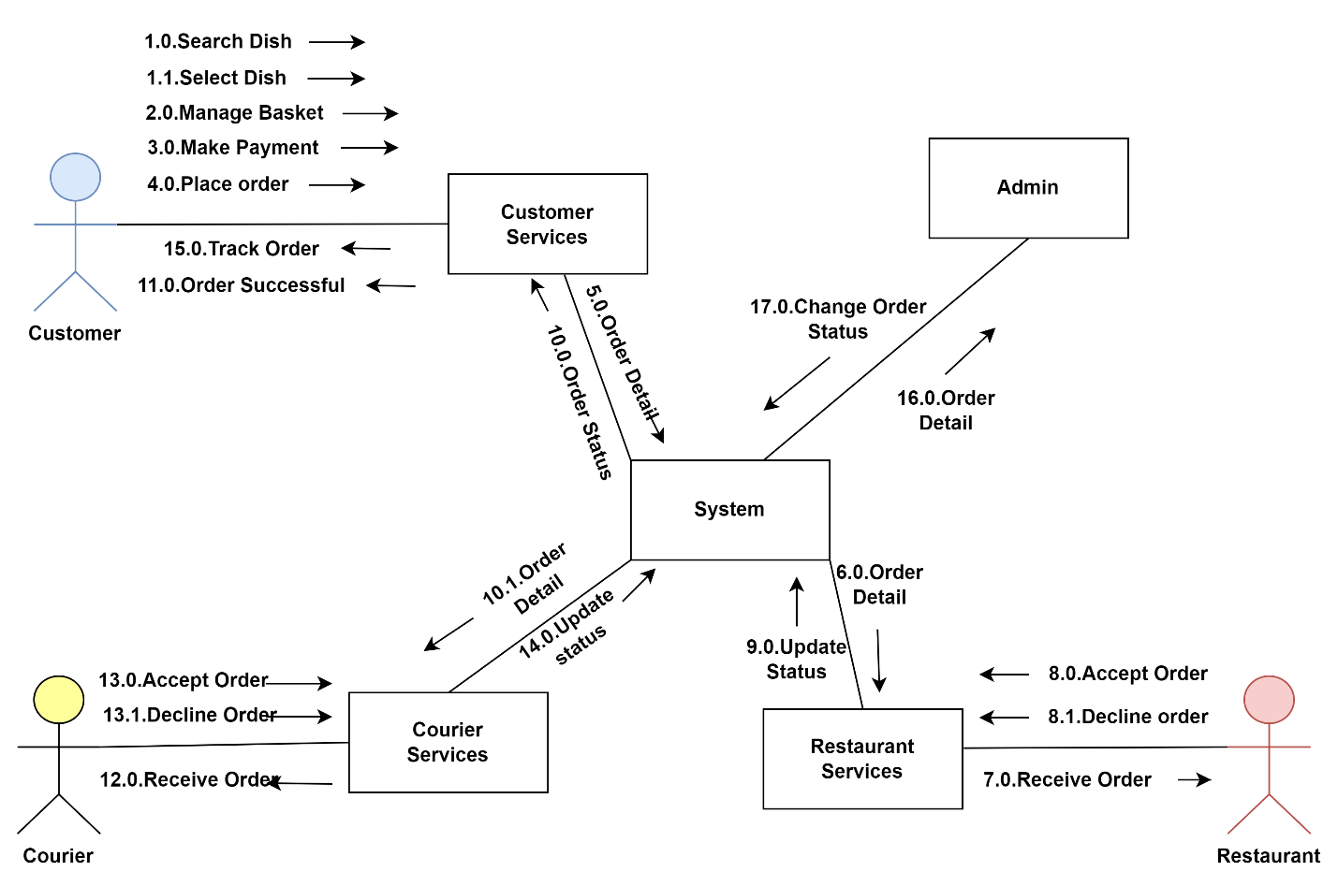
Figure 16: Collaboration Diagram of the System
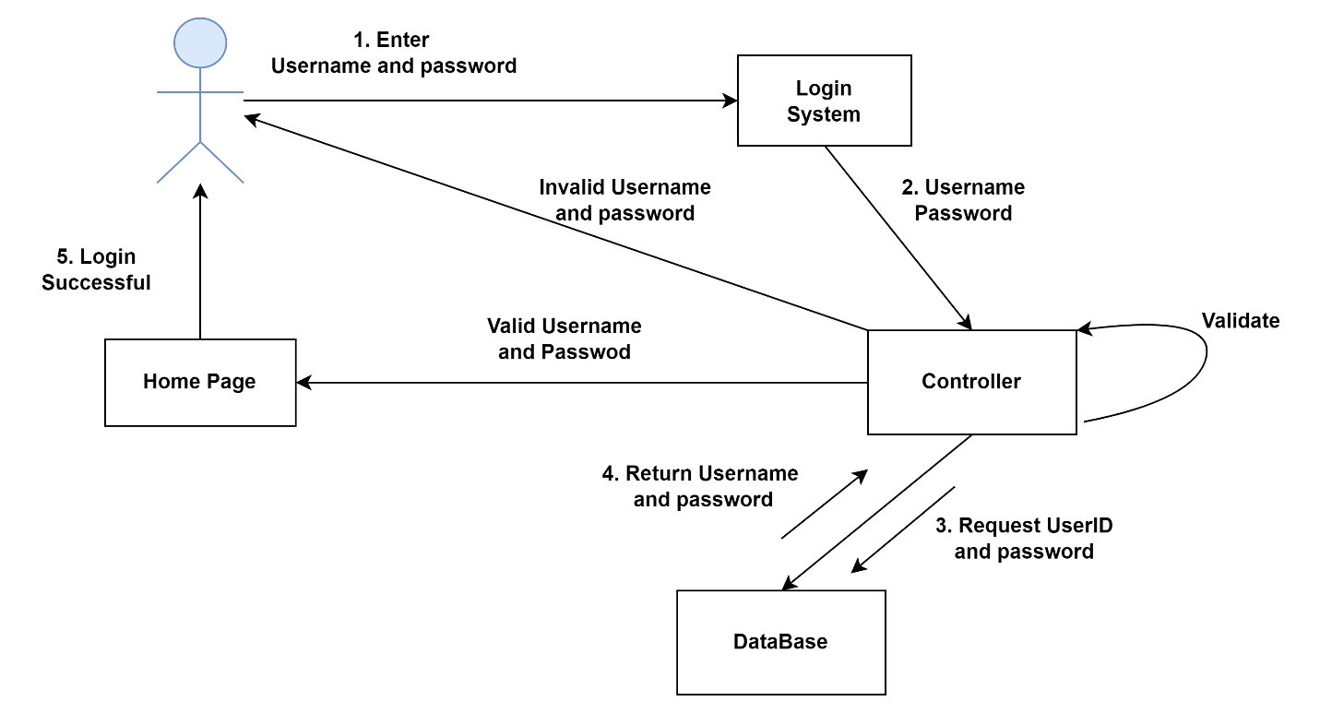
Figure 17: Collaboration Diagram for login

4.6. Component diagram
The way that a system's pieces are physically arranged is shown on component diagrams. It also demonstrates the security infrastructures that are being used and the components or objects that are accessible to whom. The diagram is recreated below.
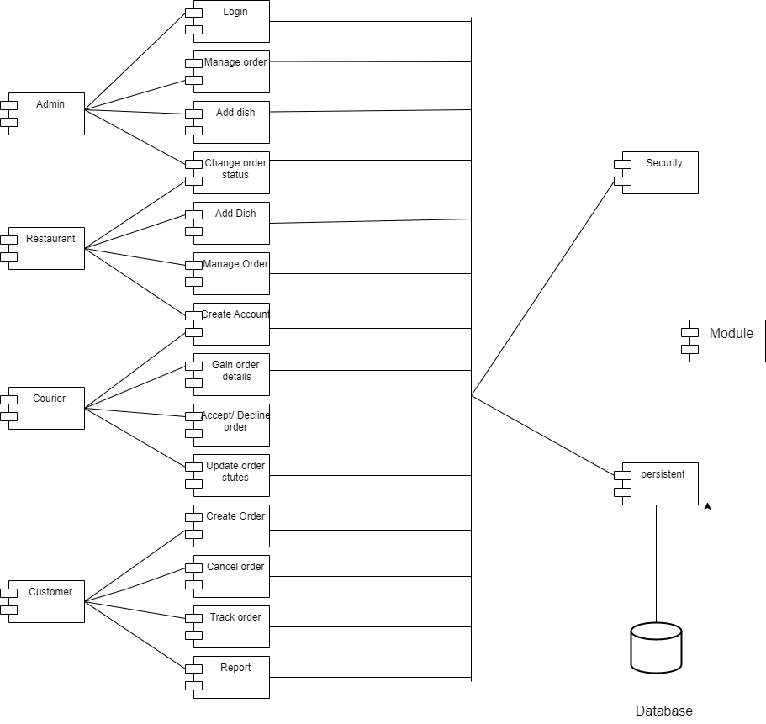

Figure 18: Component diagram

4.8. Persistence modeling
Persistence modelling is the method used to explain the design of the database, which is frequently the data base, to users and developers. It is also employed to describe the persistence data aspect of the system. The image below displays the persistence diagram for the system.
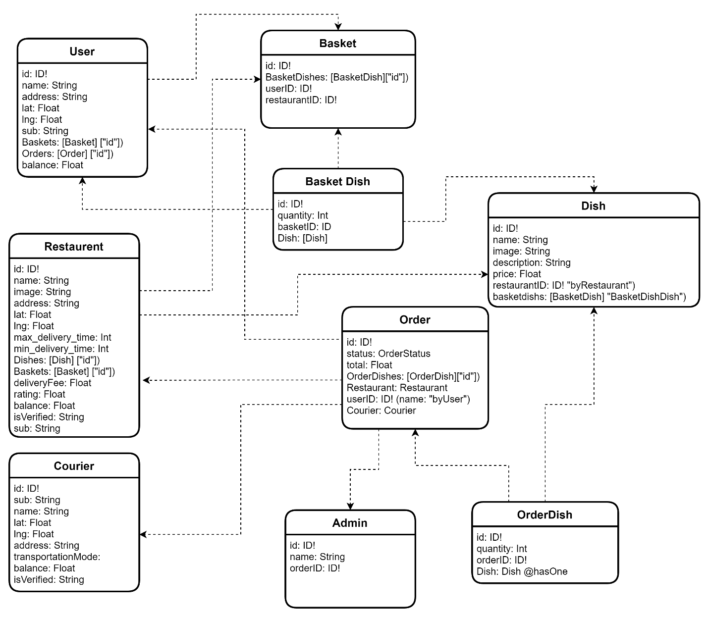
Figure 19 Persistence Diagram

Chapter 5

6. Conclusions and Recommendation
6.1. Conclusion
Throughout the duration of this project, we have acquired an extensive range of competencies related to website development through the use of various development tools and environments. These experiences have required us to undertake comprehensive research, contributing to our well-rounded and diverse understanding of the field. Furthermore, we have honed our collaborative teamwork skills, ensuring efficient project management.
The primary goal of our system is to provide an effective solution to the complexities surrounding food ordering and delivery by leveraging the benefits of a web-based platform. Our system incorporates React to develop its websites and node to develop its web backend application, enabling seamless access to our services across a variety of devices. Our database will be hosted on MongoDB, ensuring a secure, reliable and scalable platform for our business.
Our main aim of the project in solving this problem by:
- Order management: A web-based system can streamline the process of managing orders, including order placement, payment processing, and delivery tracking.
- Efficiency: By automating many of the processes involved in food ordering and delivery, a web-based system can help businesses reduce the time and resources needed to manage their operations.
- Cost savings: By eliminating the need for businesses to invest in their own IT infrastructure, a web-based system can provide significant cost savings over traditional on premise solutions.
- Cross-platform compatibility: React and node enable businesses to build applications that can run on web, providing a seamless user experience across web browsers.
- Flexibility: React and node enable businesses to build modular and reusable components, making it easier to develop and maintain complex applications.
- Security: MongoDB offers multiple layers of security to protect data and applications, including access controls, firewalls, and encryption, ensuring that sensitive information is kept secure.

6.2 .Recommendation
- We recommend a stable internet connection for the systems to integrate seamlessly.
- Multi-language support: We recommend future developers add support for multiple languages to make the platform accessible to a wider audience. English—the sole language the system use— is not a native language in Ethiopia and supporting multiple native languages will make the system more accessible to users.
- Loyalty programs: We recommend future developers add a loyalty program feature that rewards customers for repeat orders and incentivizes them to continue ordering from the platform.
- Social media integration: We recommend future developers add features that allows customers to share their orders and experiences on social media platforms, helping to promote the platform and build brand awareness.
- Analytics and reporting: We recommend future developers to incorporate analytics and reporting functionality can provide businesses with valuable insights into customer behavior and preferences, enabling them to make informed decisions about their products and services.
- Integration with third-party services: We recommend future developers integrate the system with third-party services such as payment gateways, delivery services, and inventory management systems can help businesses streamline their operations and improve efficiency.
- None Visual Interface: We recommend future developers add non-visual interfaces that help the visually impaired users navigate through the system to order food.
- In-app chat: We recommend future developers add an in-app chatting mechanism that enables customers to chat and recommend dishes to each other.

References

[1] | Grubtech, "How did food delivery start?," [Online]. Available: https://www.grubtech.com/blog/history-of-food-delivery#:~:text=The%20first%20recorded%20food%20delivery,famous%20pizza%20maker%20Rafaele%20Esposito..
[2] | emerald, "The Rise of online food delivery during the covid19 pandemic," [Online]. Available: https://www.emerald.com/insight/content/doi/10.1108/EJMBE-04-2021-0128/full/html.
[3] | Addis Fortune, "Delivery Services Fill Food Industry Gap In Addis," 24 June 2022. [Online]. Available: https://addisfortune.news/delivery-services-fill-food-industry-gap-in-addis/.
[4] | I. Ghosh, "These will be the most important cities by 2035," World Economic Forum, 21 October 2019. [Online]. Available: https://www.weforum.org/agenda/2019/10/cities-in-2035/. [Accessed 06 June 2022].
[5] | P. Gilbert, "Only 20% of Ethiopians are online," Connecting Africa, 15 3 2021. [Online]. Available: https://www.connectingafrica.com/author.asp?section_id=761&doc_id=768066.
[6] | V. DUONG, "08 Best Software Development Methodologies," Savvycom, 16 6 2022. [Online]. Available: https://savvycomsoftware.com/blog/best-software-development-methodologies/.
[7] | Tech Target, "What is a use case diagram?," [Online]. Available: https://www.techtarget.com/whatis/definition/use-case-diagram.
[8] | T. contributer, "Techtarget," may 2019. [Online].
[9] | Lucid Chart, "UML Sequence Diagram Tutorial," [Online]. Available: https://www.lucidchart.com/pages/uml-sequence-diagram#:~:text=A%20sequence%20diagram%20is%20a,to%20document%20an%20existing%20process..
[10] | Lucid Software, "How to Make a UML Sequence Diagram," YouTube, 27 August 2018. [Online]. Available: https://youtu.be/pCK6prSq8aw. [Accessed 24 June 2022].
[11] | smartdraw, "Tips for Effective UML Diagrams," [Online]. Available: https://www.smartdraw.com/uml-diagram/uml-diagram-tips.htm.

